Cameron Lewis
CAP4611
Nov 7th 2025
5593788
Assignment 5
- Kernal Logic Regression
  - Polynomial Kernel (p=2):
Training error 40.3%
Validation error 34.0%
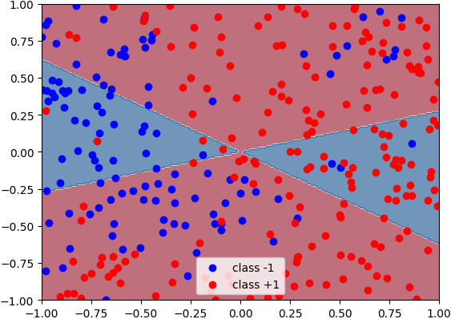
Gaussian RBF Kernel (σ=0.5):
Training error 12.7%
Validation error 11.0%
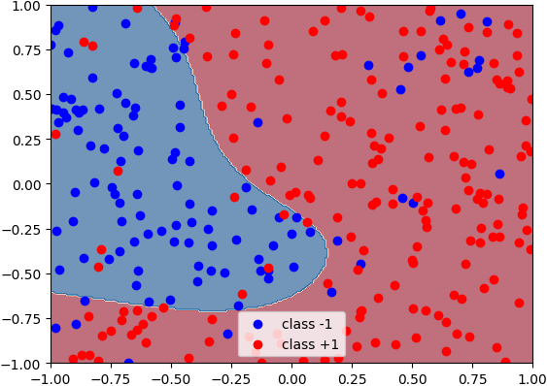
  - Best training: σ=0.01, λ=0.0001, error=0.0%
Best validation: σ=0.1, λ=1.0, error=12.0%
for i, sigma in enumerate(sigmas):
for j, lammy in enumerate(lammys):
kernel = GaussianRBFKernel(sigma=sigma)
loss_fn = KernelLogisticRegressionLossL2(lammy=lammy)
optimizer = GradientDescentLineSearch()
model = KernelClassifier(loss_fn, optimizer, kernel)
model.fit(X_train, y_train)
train_errs[i, j] = np.mean(model.predict(X_train) != y_train)
val_errs[i, j] = np.mean(model.predict(X_val) != y_val)
# Find best hyperparameters
best_train_idx = np.unravel_index(np.argmin(train_errs), train_errs.shape)
best_val_idx = np.unravel_index(np.argmin(val_errs), val_errs.shape)
print(
f"Best training: σ={sigmas[best_train_idx[0]]}, λ={lammys[best_train_idx[1]]}, error={train_errs[best_train_idx]:.1%}")
print(
f"Best validation: σ={sigmas[best_val_idx[0]]}, λ={lammys[best_val_idx[1]]}, error={val_errs[best_val_idx]:.1%}")
# Train and plot model with best training error hyperparameters
best_train_sigma = sigmas[best_train_idx[0]]
best_train_lammy = lammys[best_train_idx[1]]
kernel = GaussianRBFKernel(sigma=best_train_sigma)
loss_fn = KernelLogisticRegressionLossL2(lammy=best_train_lammy)
optimizer = GradientDescentLineSearch()
model_best_train = KernelClassifier(loss_fn, optimizer, kernel)
model_best_train.fit(X_train, y_train)
fig = plot_classifier(model_best_train, X_train, y_train)
savefig("logRegRBF_best_train.png", fig)
plt.close(fig)
# Train and plot model with best validation error hyperparameters
best_val_sigma = sigmas[best_val_idx[0]]
best_val_lammy = lammys[best_val_idx[1]]
kernel = GaussianRBFKernel(sigma=best_val_sigma)
loss_fn = KernelLogisticRegressionLossL2(lammy=best_val_lammy)
optimizer = GradientDescentLineSearch()
model_best_val = KernelClassifier(loss_fn, optimizer, kernel)
model_best_val.fit(X_train, y_train)
fig = plot_classifier(model_best_val, X_train, y_train)
savefig("logRegRBF_best_val.png", fig)
plt.close(fig)

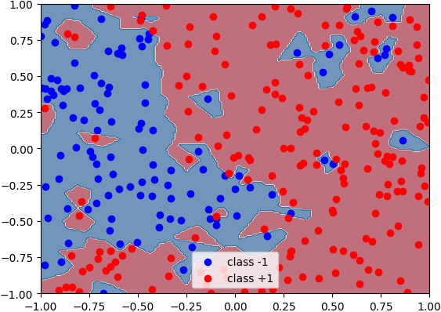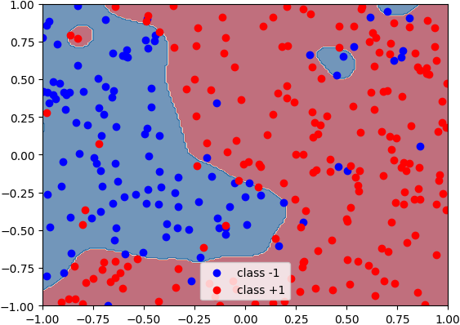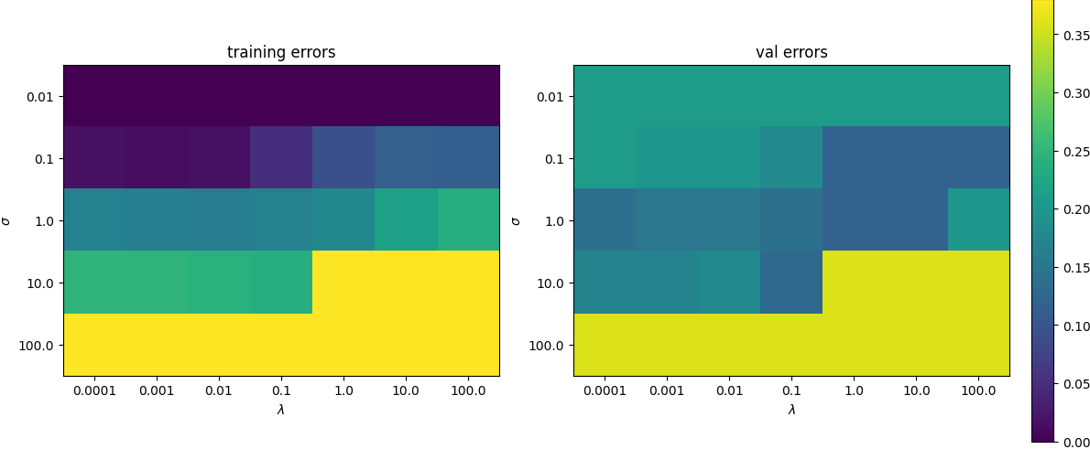
  - The smallest σ and λ values minimize training error, which is exactly what id expect and The parameters demonstrate normal bias-variance tradeoff. The gap between values is a sign of overfitting though
- Map Estimation
  - $f\left(w\right)= \frac{1}{2}∑ᵢ\frac{{\left(wᵀxᵢ - yᵢ\right)}^{2}}{σᵢ^{2}} + λ‖w‖₁$
  - $f(w) = \frac{1}{2}‖Xw - y‖₁ + \frac{1}{2σ^{2}}‖w‖²$
  - $f(w) = \frac{ν+1}{2}∑ᵢ log(1 +\frac{{\left(wᵀxᵢ - yᵢ\right)}^{2}}{ν}) + \frac{λ}{2}‖w - µ‖²$
  - $f(w) = ∑ᵢ [exp(wᵀxᵢ) - yᵢwᵀxᵢ]$
- Principle Component Analysis
  - $[\frac{1}{\sqrt{6}}, -\frac{2}{\sqrt{6}},\frac{1}{\sqrt{6}}]$
0
$\frac{11}{6}$

pca = PCAEncoder(k=2)
pca.fit(X_train_standardized)
Z = pca.encode(X_train_standardized)
fig, ax = plt.subplots()
ax.scatter(Z[:, 0], Z[:, 1])
for i in random_is:
ax.annotate(animal_names[i], xy=Z[i, :])
ax.set_xlabel('PC 1')
ax.set_ylabel('PC 2')
savefig("animals_pca.png", fig)
# Find traits with largest influence
print(f"Largest influence on PC1: {trait_names[np.argmax(np.abs(pca.W[0, :]))]}")
print(f"Largest influence on PC2: {trait_names[np.argmax(np.abs(pca.W[1, :]))]}")

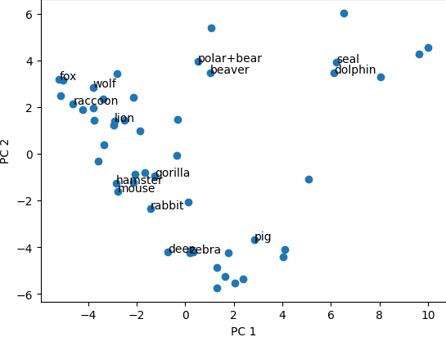
PC1: furry
PC2: grazer
  - Variance explained by k=2: 30.19%
Number of PCs required for 50% variance: 5
- Stochastic Gradient Descent

print("Reference:")
loss_fn = LeastSquaresLoss()
optimizer = GradientDescentLineSearch()
model = LinearModel(loss_fn, optimizer, check_correctness=False)
model.fit(X_train, y_train)
print(f"Training MSE: {((model.predict(X_train) - y_train) ** 2).mean():.3f}")
print(f"Validation MSE: {((model.predict(X_val) - y_val) ** 2).mean():.3f}")
# SGD with different batch sizes
batch_sizes = [1, 10, 100]
for batch_size in batch_sizes:
print(f"\nSGD with batch_size={batch_size}:")
loss_fn = LeastSquaresLoss()
base_optimizer = GradientDescent(max_evals=1) # only 1 step per batch
lr_getter = ConstantLR(multiplier=0.0003)
optimizer = StochasticGradient(
base_optimizer=base_optimizer,
learning_rate_getter=lr_getter,
batch_size=batch_size,
max_evals=10 # 10 epochs
)
model = LinearModel(loss_fn, optimizer, check_correctness=False)
model.fit(X_train, y_train)
train_mse = ((model.predict(X_train) - y_train) ** 2).mean()
val_mse = ((model.predict(X_val) - y_val) ** 2).mean()
print(f"Training MSE: {train_mse:.3f}")
print(f"Validation MSE: {val_mse:.3f}")

for batch size 1 and 10 it stayed the same and for 100 it became
Training MSE: 0.178
Validation MSE: 0.177

class ConstantLR(LearningRateGetter):
def get_learning_rate(self):
"""YOUR CODE HERE FOR Q4.2"""
self.num_evals += 1
return self.multiplier
class InverseLR(LearningRateGetter):
def get_learning_rate(self):
"""YOUR CODE HERE FOR Q4.2"""
self.num_evals += 1
return self.multiplier / self.num_evals
class InverseSquaredLR(LearningRateGetter):
def get_learning_rate(self):
"""YOUR CODE HERE FOR Q4.2"""
self.num_evals += 1
return self.multiplier / (self.num_evals ** 2)
class InverseSqrtLR(LearningRateGetter):
def get_learning_rate(self):
"""YOUR CODE HERE FOR Q4.2"""
self.num_evals += 1
return self.multiplier / np.sqrt(self.num_evals)

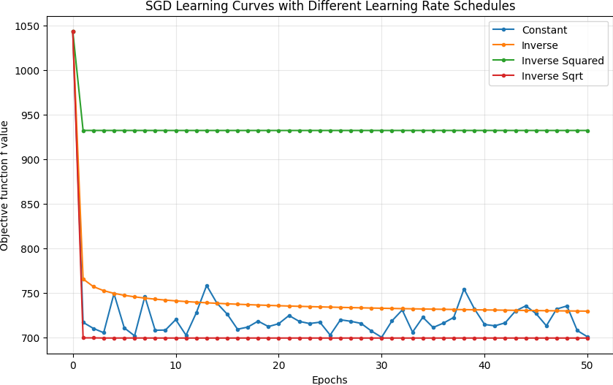
Constant and Inverse and Inverse Sqrt
- Short Answer Questions
5.1. The other normal equations are more efficient when n >> d because matrix inversion becomes computationally cheaper.
5.2. Using kernels allows K-means to find non-linear cluster boundaries.
5.3. In terms of loss functions, MLE uses only the data loss, while MAP adds a regularization term derived from the prior.
5.4. A generative model learns p(x, y) or p(x | y) and can generate new data samples, while a discriminative model learns only p(y | x) to make predictions.
5.5. Adding a constant to the kernel augments the feature space with a bias term.
5.6. The loss cannot increase since each additional principal component only decreases the reconstruction error.
5.7. If k > d, there are more principal components than dimensions. Because there are at most d orthogonal directions of variation, additional components become meaningless.
5.8. A single eigenface is stored as one row of the matrix W.
5.9.
Advantage: SGD scales better with very large datasets because it processes smaller batches rather than the full dataset and uses less memory.
Disadvantage: SGD provides an approximate solution and may converge more slowly than SVD’s exact method, and it also requires hyperparameter tuning

